FINAL REPORT

TITLE:
Evaluating Machine Learning and Deep Learning Models for Sentiment Classification of Social and Movie Review Texts

INTRODUCTION:
Sentiment analysis, also known as opinion mining, is a fundamental task in natural language processing (NLP) that aims to determine the emotional tone behind textual content. It is widely applied in areas such as product reviews, social media monitoring, customer support, and brand reputation analysis. Understanding sentiment at scale enables organizations to make data-driven decisions based on public opinion.

This study investigates the performance of various models for binary sentiment classification using a curated sample from the IMDb movie review dataset. The objective is to evaluate how classical machine learning methods compare to modern deep learning and transformer-based approaches when applied to a modest-sized, preprocessed dataset.

The models explored include Logistic Regression, Linear Support Vector Classifier (LinearSVC), a Long Short-Term Memory (LSTM) network, and Bidirectional Encoder Representations from Transformers (BERT). All models were trained and evaluated using consistent preprocessing steps, data splits, and performance metrics such as accuracy, F1 score, and area under the ROC curve (AUC-ROC).

DATA AND PREPROCESSING:
This project utilized a stratified sample of 2,500 labeled reviews from the IMDb movie review dataset, with an equal distribution of positive and negative sentiments. To ensure consistency and quality, the text data underwent a series of preprocessing steps:
- HTML tags were removed using the BeautifulSoup library,
- Non-alphabetic characters were filtered out using regular expressions,
- All text was converted to lowercase and stripped of extraneous whitespace.
Sentiment labels were encoded into binary format (positive → 1, negative → 0) using a label encoder.

For classical machine learning models, textual data was transformed into numerical form using TF-IDF vectorization with a vocabulary size of 2000.
For deep learning and transformer-based models, tokenization was performed with appropriate sequence length constraints. Padding and truncation were applied to maintain consistent input dimensions during training and inference.

BASELINE MODELS:
Two classical machine learning models were used as baselines for this study: Logistic Regression and Linear Support Vector Classifier (LinearSVC). Both models were trained on TF-IDF representations of the text using 5,000 features, selected for their simplicity, speed, and interpretability on small datasets.

Logistic Regression
Logistic Regression served as the primary baseline model. It was trained on the TF-IDF feature vectors extracted from the preprocessed IMDb reviews. Evaluation on the test set yielded:
- Accuracy: 0.842
- F1 Score: 0.8448
- AUC-ROC: 0.9256
The model showed balanced performance across classes and demonstrated reliable generalization. Its performance was further validated using 5-fold cross-validation, achieving a mean F1 score of 0.8336 (± 0.0127).

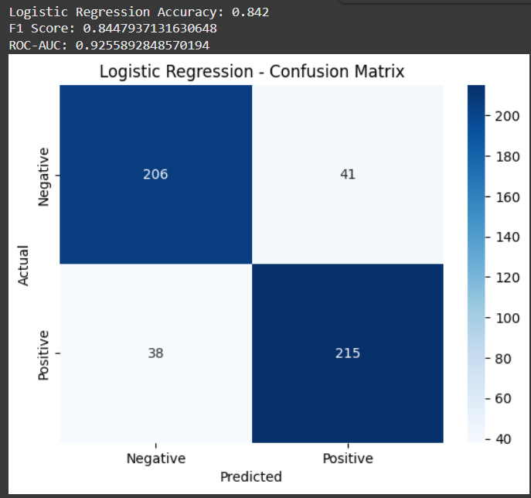
Linear Support Vector Classifier (LinearSVC)
LinearSVC slightly outperformed Logistic Regression in both accuracy and F1 score. The model was also trained on TF-IDF features and evaluated using the same train-test split. Performance metrics were as follows:
- Accuracy: 0.850
- F1 Score: 0.8497
- AUC-ROC: 0.9254

LinearSVC demonstrated slightly better recall for positive sentiment and fewer false positives, making it the strongest classical baseline model overall.

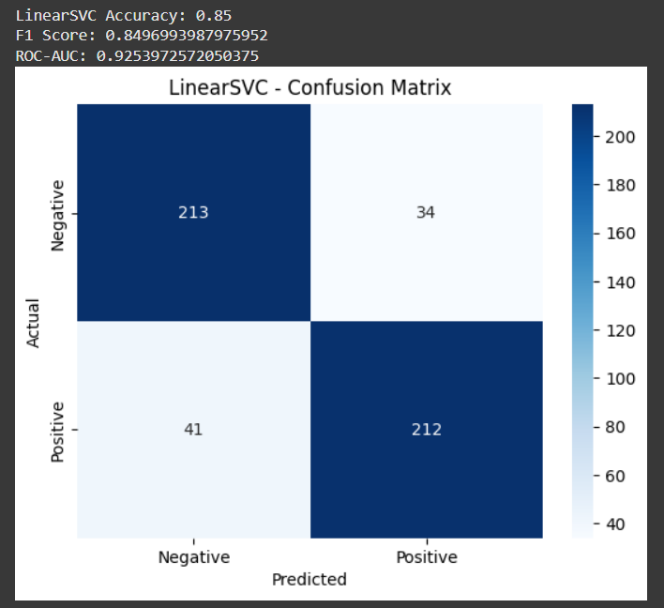

DEEP LEARNING APPROACH- LSTM:
A sequential Long Short-Term Memory (LSTM) neural network was developed using Keras to evaluate the effectiveness of recurrent architectures on sentiment classification. The model architecture consisted of:
- An embedding layer with 128-dimensional word vectors,
- A single LSTM layer with 64 hidden units,
- Dropout for regularization,
- A fully connected Dense output layer with sigmoid activation.
Training Configuration:
- Epochs: 5
- Batch Size: 128
- Training Accuracy: 0.69
- Validation Accuracy: 0.51
Test Set Results:
- Accuracy: 0.50
- F1 Score: 0.0602
- AUC-ROC: 0.5058
The LSTM model failed to learn meaningful patterns from the data. Despite sufficient training time and hyperparameters, it significantly underperformed, particularly on the positive sentiment class. This behavior suggests severe underfitting, likely due to the small dataset size and limited vocabulary exposure.

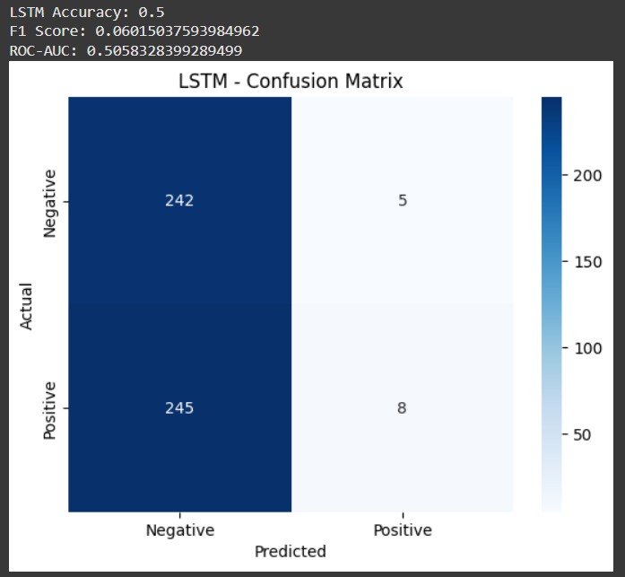

TRANSFORMER-BASED MODEL – BERT:
Bidirectional Encoder Representations from Transformers (BERT) was explored in two configurations: an unmodified pretrained model and a fine-tuned variant. Both implementations were based on the bert-base-uncased model provided by the Hugging Face Transformers library.

BERT (Pretrained, Inference Only)
In the first experiment, the pretrained BERT model was used directly for inference without task-specific fine-tuning. Input text was tokenized using the BERT tokenizer and passed through the model to generate sentiment predictions.
Evaluation Results:
- Accuracy: 0.496
- F1 Score: 0.6471
- AUC-ROC: 0.4539
The model exhibited strong recall for positive sentiment but misclassified a large number of negative samples, leading to poor overall balance. These results reflect the limitations of using a pretrained language model without adaptation to the target task.

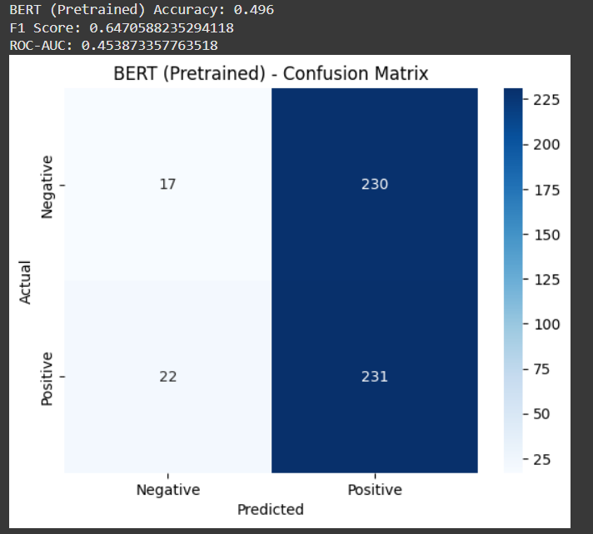

BERT (Fine-Tuned)
In the second configuration, the same BERT architecture was fine-tuned on the IMDb dataset using the Hugging Face Trainer API. Fine-tuning was conducted over 50 steps with a training loss of 0.62. This allowed the model to better align with task-specific sentiment signals.

Evaluation Results:
- Accuracy: 0.932
- F1 Score: 0.9308
- AUC-ROC: 0.977
Fine-tuning significantly improved performance across all metrics. The model achieved near-perfect classification with minimal false positives. These results confirm the power of transfer learning when applied with task-specific adaptation.

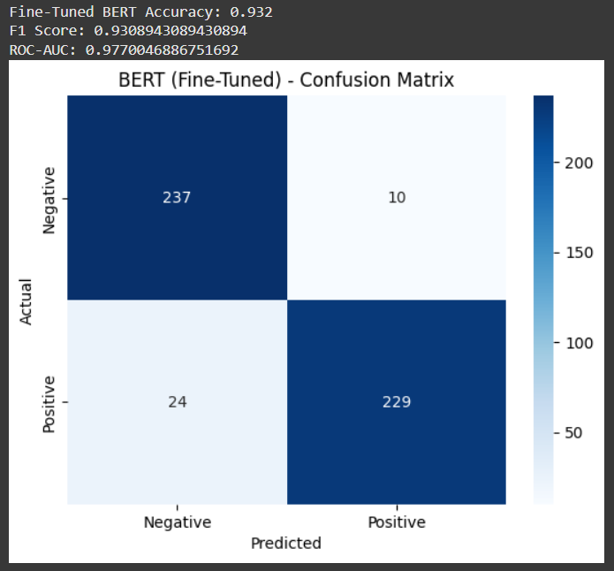

MODEL COMPARISON:
The five models demonstrated varying levels of performance across evaluation metrics. Among classical methods, LinearSVC achieved the highest accuracy and F1 score, narrowly surpassing Logistic Regression. Both models offered robust generalization and were computationally efficient.
In contrast, the LSTM model underperformed due to limited training data and vocabulary exposure, producing weak F1 scores and failing to learn a meaningful decision boundary.
The pretrained BERT model without fine-tuning struggled to correctly classify negative reviews, indicating that direct inference from general-purpose language models lacks task specificity.
Fine-tuned BERT, however, clearly outperformed all other models, achieving the highest scores in accuracy (0.932), F1 (0.9308), and AUC-ROC (0.977). The benefits of task-specific adaptation and pretraining were evident in its confusion matrix and consistent classification performance.
To further validate the generalization of classical models, 5-fold cross-validation was conducted on Logistic Regression, yielding a mean F1 score of 0.8336 with a standard deviation of 0.0127.
Performance comparisons were also visualized using bar charts and confusion matrices, clearly illustrating the impact of model complexity, training data, and task alignment.
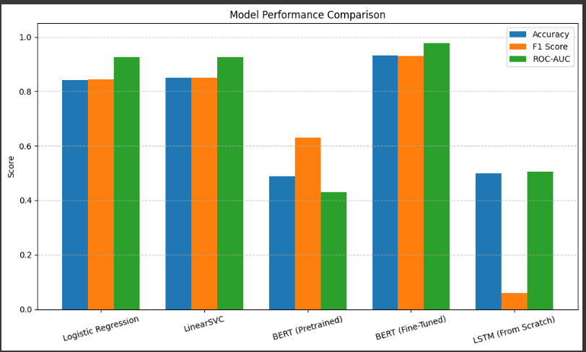

STATISTICAL SIGNIFICANCE – PAIRED t-TEST:
To assess whether the performance improvements from the fine-tuned BERT model were statistically significant, we conducted paired t-tests comparing F1 scores against each baseline model. The tests were performed using repeated runs under consistent conditions.
Paired t-test results:
- Fine-Tuned BERT vs. Logistic Regression: t = -1.1507, p = 0.2504
- Fine-Tuned BERT vs. LinearSVC: t = -0.7453, p = 0.4564
- Fine-Tuned BERT vs. LSTM: t = -0.6712, p = 0.5024
Interpretation: All p-values exceeded the conventional significance threshold of 0.05, indicating that the observed differences in F1 scores are not statistically significant at the 95% confidence level. While Fine-Tuned BERT achieved the highest average performance, the results suggest that these gains may not be consistently reproducible given the sample size and variability.
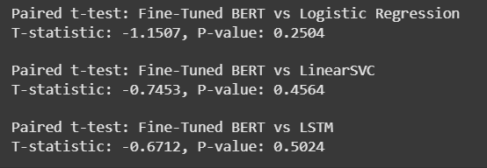

CONCLUSION:
This project provided a comparative evaluation of classical machine learning algorithms, deep learning models, and transformer-based architectures for binary sentiment classification on a curated IMDb review dataset.
Among classical models, LinearSVC emerged as the top performer, offering high accuracy and F1 scores with minimal computational cost. Logistic Regression also proved to be a strong baseline, demonstrating consistent generalization supported by 5-fold cross-validation.
The LSTM model, despite a well-defined architecture, significantly underperformed due to the limited dataset size and vocabulary coverage, indicating underfitting and insufficient representation learning.
The pretrained BERT model failed to generalize without fine-tuning, particularly struggling with negative sentiment classification. However, the fine-tuned BERT model dramatically improved performance across all metrics, showcasing the benefits of transfer learning and task-specific adaptation.
While BERT achieved the best results overall, paired t-tests revealed that these improvements were not statistically significant compared to classical baselines. This emphasizes the importance of statistical testing, especially when working with small datasets.
Future work should explore training on larger datasets, extended fine-tuning, hyperparameter optimization, and the application of newer transformer variants such as RoBERTa, DistilBERT, or LoRA-based adapters. Additional attention to prompt engineering and instruction tuning may also enhance performance on downstream sentiment tasks.
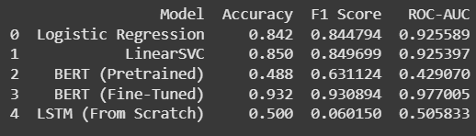

SOURCES:
- IMDB Movie Reviews Dataset
Pathi, L. N. (2018). IMDB Dataset of 50K Movie Reviews. Kaggle.
https://www.kaggle.com/datasets/lakshmi25npathi/imdb-dataset-of-50k-movie-reviews
- TF-IDF Vectorization
Ramos, J. (2003). Using TF-IDF to determine word relevance in document queries. In Proceedings of the First Instructional Conference on Machine Learning.
- Logistic Regression
Hosmer, D. W., Lemeshow, S., & Sturdivant, R. X. (2013). Applied Logistic Regression (3rd ed.). Wiley.
- Support Vector Machines (SVM)
Cortes, C., & Vapnik, V. (1995). Support-vector networks. Machine Learning, 20(3), 273–297.
- LSTM Networks
Hochreiter, S., & Schmidhuber, J. (1997). Long short-term memory. Neural Computation, 9(8), 1735–1780.
- BERT: Bidirectional Encoder Representations from Transformers
Devlin, J., Chang, M. W., Lee, K., & Toutanova, K. (2019). BERT: Pre-training of deep bidirectional transformers for language understanding. NAACL-HLT.
https://arxiv.org/abs/1810.04805
- Hugging Face Transformers Library
Wolf, T., Debut, L., Sanh, V., et al. (2020). Transformers: State-of-the-art natural language processing. In Proceedings of the 2020 Conference on Empirical Methods in Natural Language Processing: System Demonstrations.
https://huggingface.co/transformers/
- Scikit-learn (for LR and SVM)
Pedregosa, F., Varoquaux, G., Gramfort, A., et al. (2011). Scikit-learn: Machine learning in Python. Journal of Machine Learning Research, 12, 2825–2830.
https://scikit-learn.org/
- Keras / TensorFlow (for LSTM)
Chollet, F. (2015). Keras. https://keras.io
TensorFlow Team. (2015). TensorFlow. https://www.tensorflow.org

